Order Of Service

Singing: Psalm 146—CW page 120

Reading: Psalm 11

Opening Hymn: TLH 42

Reading: I John 4

Request Hymn: CW Supplement 748

Reading: John 1:35-42

Sermon Hymn: TLH 236

Sermon Text: Song Of Solomon 4:1b

Her Hair--Goats

Prayer

The Apostles’ Creed, TLH page 12

Holy Communion

The Lord's Prayer

The Blessing

Closing Hymn: TLH 50

* * * * * * * * * * *

Bible Study: Lambs: Luke 1:37; Nothing Impossible For God
Sheep: Proverbs 10:17-18


Flock Of Goats

Water
Of
Life

10 July 2016

W A T E R O F L I F E

Independent Christian Church—Conservative Lutheran Doctrine

Worship Service: 9:30 a.m. Bible Study: 10:45 a.m.

Larry Cooper, Pastor E-Mail address:
111 N. Ridge Road lcooper@wateroflife.cc
Coon Valley, WI 54623 Web Site:
Phone: (608) 452-2105 www.wateroflife.cc

* * * * * * * * * * * * * * * * * * * * * * * * * * *

Sermon Text: Song Of Solomon 4:1b

Her Hair--Goats

* * * * * * * * * * * * * * * * * * * * * * * * * * *

Song of Solomon 4:1b Thy hair is as a flock of goats, that appear from mount Gilead.

Son 4:1b your hair [makes me think of the black, wavy fleece] of a flock of [the Arabian] goats which one sees trailing down Mount Gilead [beyond the Jordan on the frontiers of the desert]. The Amplified Bible

* * * * * * * * * * *

The first thing the Bridegroom mentions about the beauty of his Bride is her eyes. Now the second thing he mentions is her hair.
The Bride’s hair is compared to a flock of goats, that appear from mount Gilead.

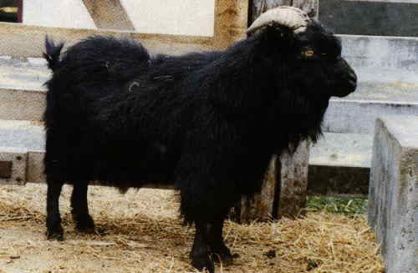

A related passage in the New Testament would be selected verses from I Corinthians 11. For reference:

1 Corinthians 11:7 For a man indeed ought not to cover his head, forasmuch as he is the image and glory of God: but the woman is the glory of the man.
:8 For the man is not of the woman; but the woman of the man.
:9 Neither was the man created for the woman; but the woman for the man.
:10 For this cause ought the woman to have power on her head because of the angels.
:11 Nevertheless neither is the man without the woman, neither the woman without the man, in the Lord.
:12 For as the woman is of the man, even so is the man also by the woman; but all things of God.
:13 Judge in yourselves: is it comely that a woman pray unto God uncovered?
:14 Doth not even nature itself teach you, that, if a man have long hair, it is a shame unto him?
11:15 But if a woman have long hair, it is a glory to her: for her hair is given her for a covering.

